PATTERN RECOGNITION
SEMESTER PROJECT REPORT

WINE QUALITY CLASSIFICATION
USING PCA, FDA AND CLASSICAL PATTERN RECOGNITION CLASSIFIERS

Submitted by
Krupa Amulya T
S20200020307

Abstract
Wine quality assessment is formulated as a supervised three-class pattern recognition problem using physicochemical measurements. Red- and white-wine datasets are combined, exact duplicate records are removed within each wine type, and the original quality scores are grouped into Low (≤4), Medium (5–6) and High (≥7). The cleaned dataset contains 5,320 samples and 11 chemical input attributes. The study analyzes feature statistics and class imbalance, then compares original standardized features with Principal Component Analysis (PCA) and Fisher Discriminant Analysis (FDA). Classical classifiers include k-Nearest Neighbours (KNN), Gaussian Naive Bayes and a class-specific Mahalanobis-distance classifier. Random oversampling is also examined for KNN. Stratified five-fold cross-validation is used, with standardization and feature transformations fitted within each training fold. PCA-KNN obtains the highest reported mean accuracy (78.31% ± 0.78), while original-feature KNN obtains the highest mean macro-F1 among the reported methods (49.57% ± 3.87). The results reveal that the majority Medium class is recognized substantially better than the minority Low class. The work therefore evaluates feature representations using class-sensitive measures as well as overall accuracy.
Keywords: Pattern recognition; wine quality; PCA; Fisher discriminant analysis; KNN; Gaussian Naive Bayes; Mahalanobis distance; class imbalance.

1. Introduction
Wine quality assessment is relevant to production quality control and product consistency. Laboratory-measured physicochemical properties provide numerical descriptors that can be analyzed using pattern recognition methods. This project uses these measurements to assign a wine sample to one of three quality categories.
The work emphasizes the role of feature representation in classical classification. The original standardized feature space is compared with PCA, which summarizes variance, and FDA, which seeks directions that separate labelled classes. Multiple classical classifiers are evaluated on these representations.

2. Problem Definition and Objectives
Given a sample represented by 11 physicochemical attributes, predict one of three categories: Low, Medium or High. The target is derived from the original integer quality score using fixed thresholds: Low for scores up to 4, Medium for scores 5 or 6, and High for scores of 7 or above.

2.1 Objectives
- Combine red- and white-wine datasets and prepare a consistent labelled dataset.
- Analyze feature statistics, correlations and class distribution.
- Implement PCA and FDA using training data only.
- Compare KNN, Gaussian Naive Bayes and Mahalanobis-distance classification.
- Investigate random oversampling as a training-only experiment.
- Evaluate models using stratified cross-validation, accuracy, macro-F1, balanced accuracy and class-wise metrics.

3. Dataset Description
The project uses red-wine and white-wine quality CSV files obtained from Kaggle. Each contains 11 physicochemical input attributes and an integer quality score. The 11 inputs are fixed acidity, volatile acidity, citric acid, residual sugar, chlorides, free sulfur dioxide, total sulfur dioxide, density, pH, sulphates and alcohol. The red- and white-wine CSV files used in this project were obtained from Kaggle: https://www.kaggle.com/datasets/greatdk/wine-quality-dataset.
Dataset | Original samples | Input attributes | Target
Red wine | 1,599 | 11 chemical features | Quality score
White wine | 4,898 | 11 chemical features | Quality score
Combined after within-type deduplication | 5,320 | 11 chemical features + metadata | Low / Medium / High

A WineType field is added before combination. Exact duplicate rows are removed independently within red and white wine using the 12 numeric columns (11 inputs and quality). Two numeric records occur in both source datasets; they are retained because the wine-type metadata distinguishes them.

3.1 Class definition and distribution
Class | Original quality score | Samples | Percentage
Low | ≤ 4 | 236 | 4.44%
Medium | 5–6 | 4,075 | 76.60%
High | ≥ 7 | 1,009 | 18.97%
Total | — | 5,320 | 100.00%

The target is highly imbalanced. Medium samples form over three quarters of the cleaned dataset, while Low samples represent only 4.44%. Accuracy alone is therefore insufficient to characterize model performance.
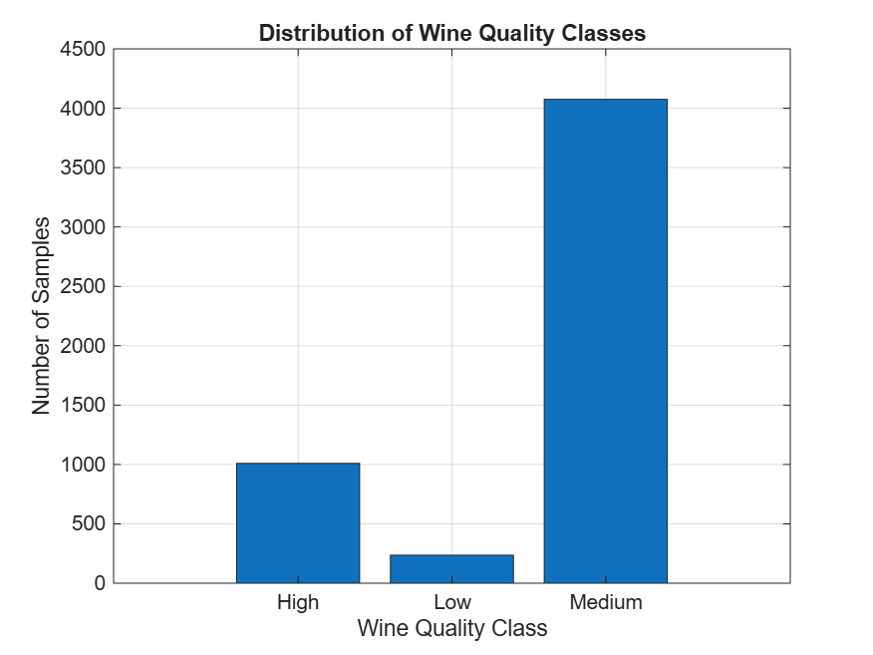
Figure 1. Distribution of the three wine-quality classes in the cleaned dataset.

4. Preprocessing and Exploratory Analysis

4.1 Duplicate and missing-value checks
The implementation removes exact duplicates separately within each wine type. The combined data are checked for missing values and duplicate numeric records. The recorded analysis found zero missing values after cleaning. The duplicate analysis recorded 240 duplicates in the original red dataset and 937 in the original white dataset before within-type removal; two numeric records were common to both source datasets.

4.2 Statistical analysis
For each of the 11 features, the implementation calculates mean, variance and standard deviation. It also computes the covariance matrix and Pearson correlation matrix. A correlation heatmap is saved in the Results directory. These statistics describe feature scale, spread and linear relationships.
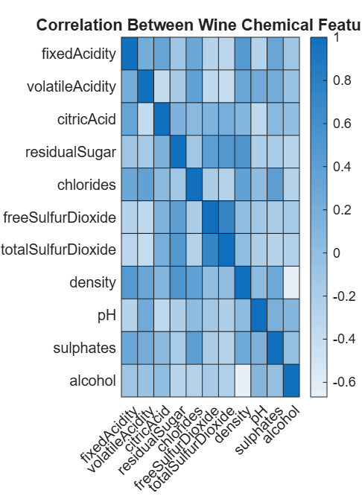
Figure 2. Pearson correlation heatmap for the 11 physicochemical input features.

4.3 Standardization and partitioning
A stratified 80:20 training/testing partition is used for the holdout experiment. Each feature is standardized using the training-set mean and standard deviation; the same parameters are applied to the test set. A zero standard deviation is replaced with one. The five-fold experiments repeat this procedure independently within each fold.

5. Pattern Recognition Methods

5.1 Principal Component Analysis
PCA is an unsupervised linear transformation that finds orthogonal directions maximizing projected variance. Let X be the standardized training matrix and S its sample covariance matrix. Eigen-decomposition solves S v_i = λ_i v_i. Eigenvalues are sorted in descending order, and the smallest number of leading eigenvectors retaining at least 95% cumulative explained variance is selected. Training and test observations are projected using directions estimated only from the training data.
For the initial holdout training set, nine principal components retained 97.61% of variance. The number of components is recomputed within each cross-validation training fold.
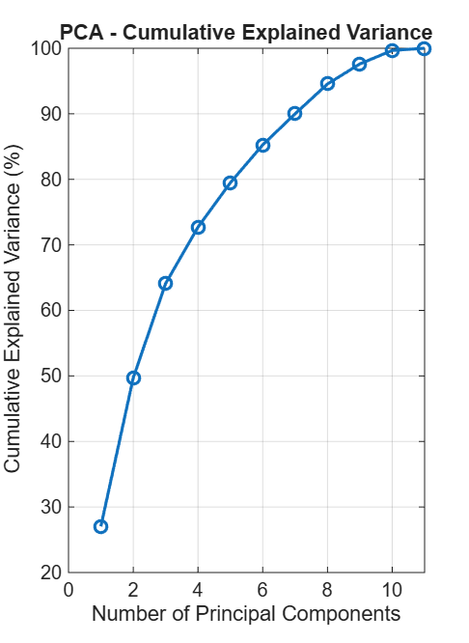
Figure 3. Cumulative explained variance obtained from PCA on the training data.

5.2 Fisher Discriminant Analysis
FDA is a supervised feature extraction method that seeks projections with high between-class scatter relative to within-class scatter. For class c, with mean μ_c and count n_c, and overall mean μ, the within-class scatter is S_W = Σ_c Σ_(x in c) (x − μ_c)(x − μ_c)^T. The between-class scatter is S_B = Σ_c n_c(μ_c − μ)(μ_c − μ)^T. Projection directions solve S_B v = λ S_W v. A small diagonal regularization term is added to S_W for numerical stability. With three classes, at most C−1 = 2 discriminant directions are retained.
FDA uses training labels to estimate its projection. Its scatter matrices and directions are recomputed from each training fold, without using held-out labels.
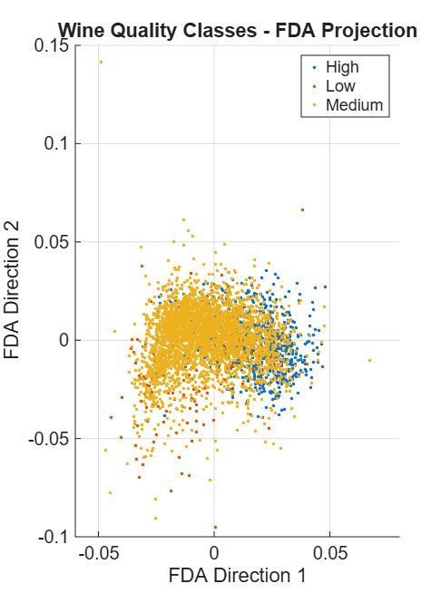
Figure 4. Two-dimensional FDA projection; class overlap indicates limited linear separability.

5.3 k-Nearest Neighbours
KNN is a non-parametric classifier that assigns a query observation the majority class among its k nearest training observations. The implementation uses k=5 and compares original standardized, PCA and FDA representations. KNN is sensitive to feature scaling and class imbalance.

5.4 Gaussian Naive Bayes
Gaussian Naive Bayes models each feature conditionally on the class using a Gaussian distribution and applies Bayes' rule to estimate the most probable class. The MATLAB implementation uses fitcnb with normal feature distributions. It is evaluated on original, PCA and FDA features.

5.5 Mahalanobis-distance classifier
The implemented classifier estimates a mean vector and covariance matrix for each class from training data. For a test vector x and class c, it calculates d_c(x) = (x − μ_c)^T Σ_c^−1 (x − μ_c), with diagonal covariance regularization, and assigns the class with the smallest distance. This implementation does not include an explicit class-prior or determinant term; it is described as a class-specific Mahalanobis-distance classifier rather than full quadratic discriminant analysis.

5.6 Random oversampling
Random oversampling is applied only to the training portion of the holdout experiment. Minority-class observations are sampled with replacement until each class reaches the size of the largest training class. The test set remains untouched and retains its original distribution. KNN is then evaluated on the original test set.

6. Experimental Methodology

6.1 Holdout experiment
A stratified 80:20 split is created with a fixed random seed. Standardization, PCA and FDA are fitted using training data only. The holdout experiment provides direct comparisons and class-wise metrics for KNN representations, oversampled KNN, Gaussian Naive Bayes and the Mahalanobis classifier.

6.2 Five-fold stratified cross-validation
Five-fold stratified cross-validation estimates generalization performance across multiple partitions. In each fold, standardization parameters are estimated from the training subset, PCA directions are estimated from the training covariance matrix, and FDA directions are estimated using training labels. Models are fitted on training data and evaluated on the held-out fold. Results are reported as mean and sample standard deviation across the five folds.

6.3 Evaluation metrics
Accuracy is the fraction of all observations classified correctly. For each class, precision = TP/(TP+FP), recall = TP/(TP+FN), and F1 = 2·precision·recall/(precision+recall). Macro-F1 is the unweighted mean of class-wise F1. Balanced accuracy is the unweighted mean of class recalls. These measures are important because class frequencies are unequal.

7. Results

7.1 Five-fold cross-validation results
Method | Accuracy mean ± SD | Macro-F1 mean ± SD | Balanced accuracy mean ± SD
KNN – Original | 78.10 ± 0.97% | 49.57 ± 3.87% | 47.87 ± 2.90%
KNN – PCA | 78.31 ± 0.78% | 49.04 ± 2.33% | 47.47 ± 1.48%
KNN – FDA | 75.58 ± 1.01% | 44.23 ± 2.75% | 43.22 ± 2.31%
Bayes – Original | 68.74 ± 0.98% | 48.67 ± 1.72% | 51.69 ± 2.10%
Bayes – PCA | 75.86 ± 0.80% | 47.66 ± 1.40% | 46.10 ± 1.17%
Bayes – FDA | 77.05 ± 0.84% | 47.48 ± 0.75% | 45.38 ± 0.65%
Mahalanobis – Original | 41.35 ± 1.11% | 38.60 ± 0.53% | 56.59 ± 1.69%

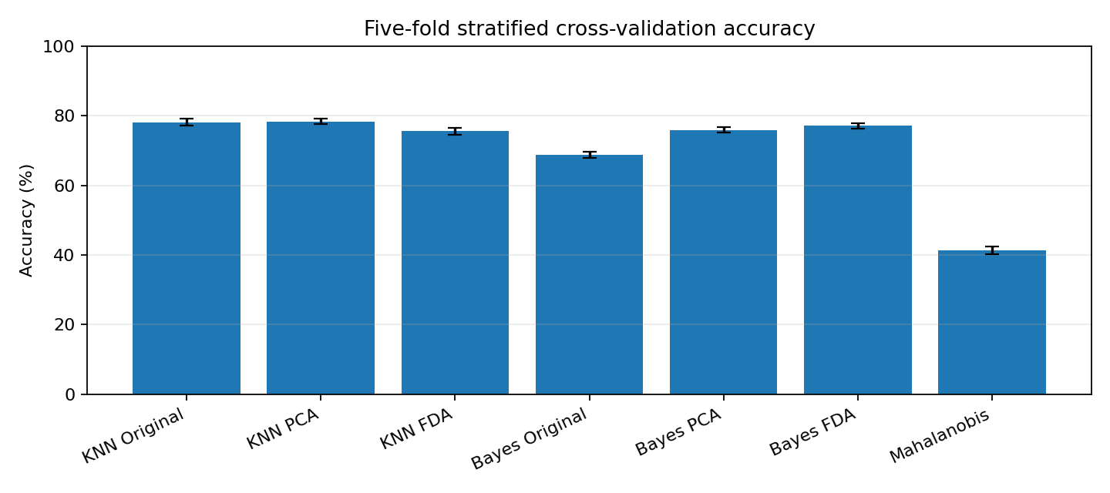
Figure 5. Five-fold stratified cross-validation accuracy; error bars show standard deviation.

7.2 KNN pooled out-of-fold confusion matrices
Matrices below pool predictions for all 5,320 observations. Rows are true classes and columns are predicted classes; class order is High, Low, Medium.
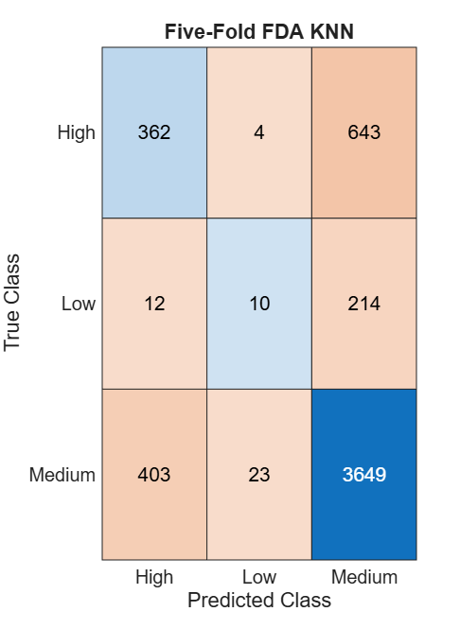
Figure 6. Pooled out-of-fold confusion matrix for KNN using FDA features.
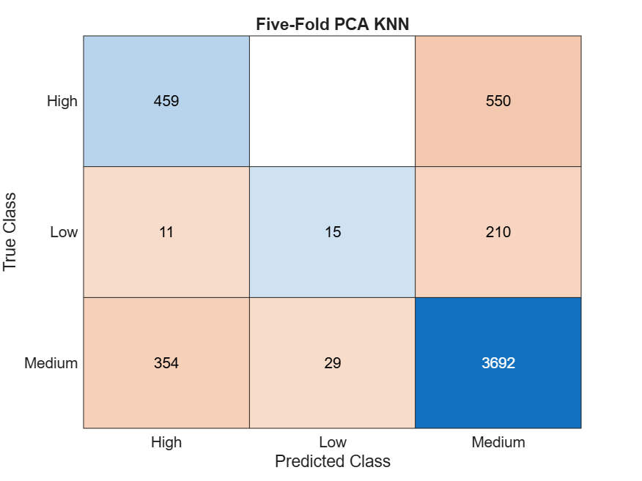
Figure 7. Pooled out-of-fold confusion matrix for KNN using PCA features.
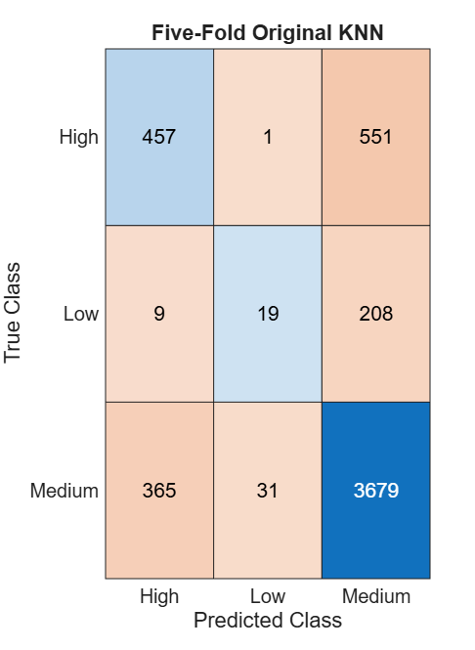
Figure 8. Pooled out-of-fold confusion matrix for KNN using original standardized features.
Original KNN | Pred High | Pred Low | Pred Medium
True High | 457 | 1 | 551
True Low | 9 | 19 | 208
True Medium | 365 | 31 | 3679

PCA KNN | Pred High | Pred Low | Pred Medium
True High | 459 | 0 | 550
True Low | 11 | 15 | 210
True Medium | 354 | 29 | 3692

FDA KNN | Pred High | Pred Low | Pred Medium
True High | 362 | 4 | 643
True Low | 12 | 10 | 214
True Medium | 403 | 23 | 3649

Model | High precision / recall | Low precision / recall | Medium precision / recall
KNN Original | 54.99% / 45.29% | 37.25% / 8.05% | 82.90% / 90.28%
KNN PCA | 55.70% / 45.49% | 34.09% / 6.36% | 82.93% / 90.60%
KNN FDA | 46.59% / 35.88% | 27.03% / 4.24% | 80.98% / 89.55%

7.3 Holdout comparison and oversampling
In the recorded 80:20 holdout experiment, KNN achieved 78.29% accuracy with original features, 78.48% with PCA and 75.47% with FDA. Gaussian Naive Bayes achieved 68.61%, 75.56% and 75.94%, respectively. The Mahalanobis-distance classifier achieved 46.24%. These holdout values are distinct from the five-fold means and must be labelled separately.
Random oversampling reduced KNN holdout accuracy to 64.29% (original features), 63.16% (PCA) and 57.14% (FDA), while increasing minority-class representation during training. This illustrates the trade-off between overall accuracy and minority-class sensitivity.
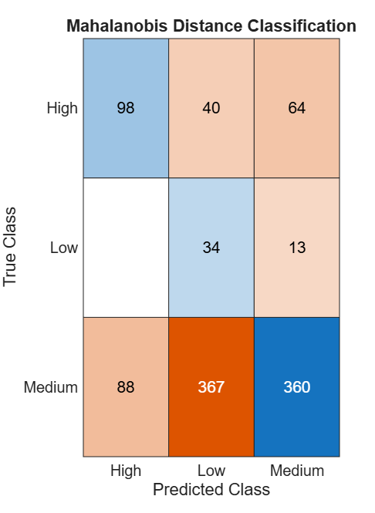
Figure 9. Holdout confusion matrix for the Mahalanobis-distance classifier; rows are true classes and columns are predicted classes.
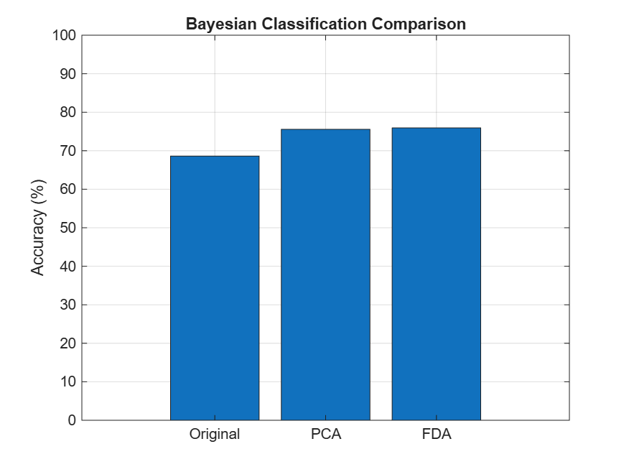
Figure 10. Holdout Gaussian Naive Bayes accuracy after original-feature, PCA and FDA representations.
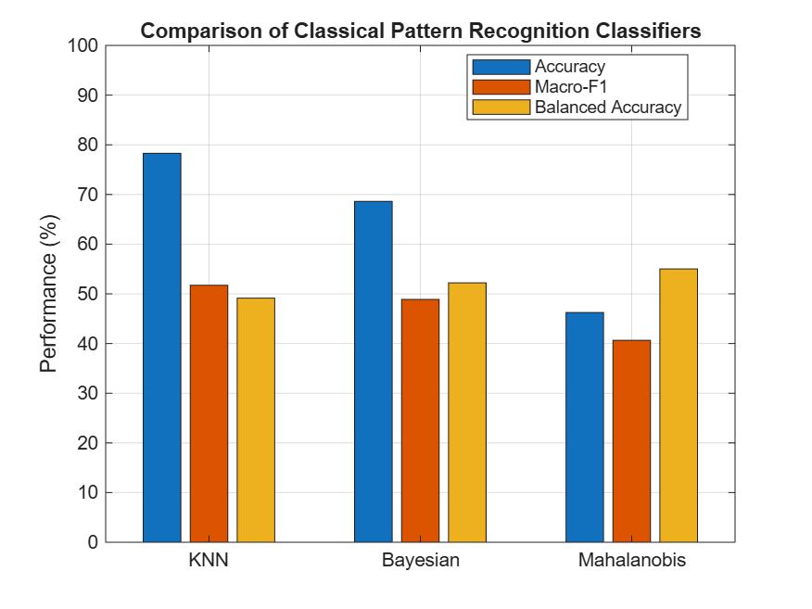
Figure 11. Holdout comparison of KNN, Gaussian Naive Bayes and Mahalanobis-distance classification using accuracy, macro-F1 and balanced accuracy.

8. Discussion
PCA produces a small increase in KNN mean accuracy relative to original features (78.31% versus 78.10%), but its mean macro-F1 is slightly lower (49.04% versus 49.57%). The accuracy gain therefore does not translate into improved unweighted class-wise F1. FDA reduces KNN accuracy and macro-F1, suggesting that the two-dimensional supervised projection does not preserve the local neighbourhood structure required by KNN in this dataset.
For Gaussian Naive Bayes, FDA has higher mean accuracy than the original-feature model, but lower macro-F1 and balanced accuracy. The Mahalanobis classifier has the lowest mean accuracy but the highest balanced accuracy among the listed five-fold methods, indicating a different trade-off across classes.
The pooled KNN confusion matrices show high Medium-class recall (approximately 89.55–90.60%), while Low-class recall is very low (approximately 4.24–8.05%). High-class recall is moderate. The model frequently assigns minority-class samples to Medium. Consequently, overall accuracy does not fully describe model quality.
The central pattern-recognition finding is that feature extraction changes the geometry and information retained by a classifier, but no single representation improves every model and every metric. PCA gives a small KNN accuracy gain; FDA does not improve KNN macro-F1 in these experiments. These are valid comparative findings and should be reported without claiming universal improvement.

9. Limitations and Future Work
- The Low class is severely under-represented, so its recall is poor and its estimates are less stable.
- The three categories are created by grouping original integer quality scores; alternative thresholds may change class balance and task difficulty.
- PCA maximizes total variance, not class separation. FDA is limited to two directions for three classes and can be sensitive to within-class scatter estimation.
- Random oversampling duplicates minority observations and can increase overfitting; class-weighted learning or other validated resampling methods could be explored.
- The Mahalanobis implementation omits explicit prior and determinant terms; other discriminant formulations could be compared.
- The final bibliography should include the exact Kaggle dataset page and any external references consulted.
Future work may investigate feature selection, class-weighted classifiers, alternative neighbourhood metrics, covariance regularization, threshold sensitivity and repeated stratified cross-validation with additional random seeds. All preprocessing and feature extraction must remain fitted on training data only.

10. Conclusion
This project implemented a supervised pattern-recognition pipeline for three-class wine quality classification using 5,320 cleaned red- and white-wine samples and 11 physicochemical attributes. Statistical analysis, PCA, FDA, KNN, Gaussian Naive Bayes, a Mahalanobis-distance classifier and a training-only random oversampling experiment were evaluated. Five-fold stratified cross-validation with fold-specific preprocessing was used to reduce data leakage and report mean ± standard deviation. PCA-KNN produced the highest mean accuracy at 78.31% ± 0.78, while original-feature KNN produced the highest mean macro-F1 at 49.57% ± 3.87 among the listed methods. The Low class remained difficult to identify because it represents only 4.44% of the cleaned data. The results demonstrate that feature extraction and classifier choice must be assessed using class-sensitive metrics as well as accuracy.

References
[1] greatdk. Wine Quality Dataset [Data set]. Kaggle. https://www.kaggle.com/datasets/greatdk/wine-quality-dataset.
[2] MathWorks. MATLAB Documentation. https://www.mathworks.com/help/matlab .
[3] Fisher, R. A. (1936). The use of multiple measurements in taxonomic problems. Annals of Eugenics, 7(2), 179–188.
[4] Jolliffe, I. T., & Cadima, J. (2016). Principal component analysis: A review and recent developments. Philosophical Transactions of the Royal Society A, 374, 20150202.

Appendix A: Individual Contribution
This is an individual project. I independently carried out topic selection, dataset acquisition, data cleaning, exploratory and statistical analysis, implementation of PCA and FDA, implementation and comparison of classical classifiers, class-balancing experiments, cross-validation, metric computation, visualization, interpretation of results, code organization and report preparation.

Appendix B: Repository and Reproducibility
Public GitHub repository: https://github.com/krupaamulya-dot/wine_quality_classification

